**A Perspective of Inequality and Taxation in Indonesia**

As we know, Directorate General of Taxes is undergoing a tax reform as part of the Ministry of Finance Strategic Program until 2020. Even though this is not the first tax reform in DGT, this time we have hope to visualize a stronger, more credible and accountable tax institution. However, the challenge of this third tax reform in Indonesia is also bigger to optimize tax revenue. Supported by five pillars of reform that consists of organization, human resources, information technology and database, business process and regulations, this program is manifestation of consolidation, acceleration, and continuity of a true tax reform with an expectation.

One of the highlights of a tax reform in many countries, especially in the developing countries is how to reduce inequality of income and wealth that always grow. If in the developed countries, the income tax, especially personal income tax has long been viewed as a primary instrument for income redistribution, does it make sense for developing countries, including our country also to rely on it? let's see the data of our tax ratio (as percentage of GDP) and personal income tax receipts as a percentage of total taxes collected and also percentage of population paying personal income taxes) below:

|  |  |  |
| --- | --- | --- |
| No. | Role of Personal Income Tax | Percentage (%) |
| 1. | Income tax receipts as a percentage of GDP | 11 |
| 2. | Personal income tax receipts as a percentage of total taxes collected | 11,53 |
| 3. | Percentage of population paying personal income taxes | 2,88 |

Note:

1. Personal Income Tax Receipts in 2015 (Art 21, 25/29): 122.302,22 Million IDR
2. Total Tax Collected (incl. Oil & Gas) in 2015: 1.060.860,57 Million IDR
3. The number of Individual Taxpayers (Non-Employee) in 2015: 5.239.385
4. The number of Individual Taxpayers (Employee) in 2015: 22.332.086
5. Total Number of individual Taxpayers in 2015: 27.571.471
6. The number of Individual Taxpayers (Non-Employee) in 2015 who paid taxes: 612.881
7. The number of Individual Taxpayers (Employee) in 2015who paid taxes: 181.537
8. Total Number of individual Taxpayers in 2015 who paid taxes: 794.418

*source: www.pajak.go.id and DGT's Annual Report 2015*

Now let's estimate the relative amounts of revenue raised under the personal income tax system from income from labor and income from capital and their relative percentages:

1. Personal Income Tax Receipts in 2015 (Art 21, 25/29): 122.302,22 Million IDR
2. The number of Individual Taxpayers (Non-Employee) in 2015: 5.239.385
3. The number of Individual Taxpayers (Employee) in 2015: 22.332.086
4. Total Number of individual Taxpayers in 2015: 27.571.471
5. Revenue raised under the personal income tax system from income from labor (in relative %): 81%
6. Revenue raised under the personal income tax system from income from Capital/Non-Labor (in relative %): 19%

*source: www.pajak.go.id and DGT's Annual Report 2015*

In an article which was written by Winarno Zain, a commissioner in a publicly listed oil and gas service company, according to the World Bank, Indonesia has one of the highest wealth concentrations in the world. The richest 10 percent of Indonesians own an estimated 77 percent of the country’s wealth. Half of the country’s assets are owned by the richest 1 percent. Worse, the concentration of wealth is increasing faster than in other countries. Income from these assets sometimes is taxed at a lower rate than worker income and has a much lower rate of tax compliance. This means the rich are able to save a larger percentage of their income, increasing inequality in the future. The figures are based on several surveys, but it is known that getting the rich households as survey respondents is more difficult than getting answers from the poor. It is likely that the outcome of the surveys understates the extent of the wealth concentration, so that the actual wealth concentration is worse than stated in the surveys. The widening gap in income should open our eyes to the failure of tax policies as an instrument of income distribution. Tax compliance remains low and tax evasion among high earners is still common. This raises the question of equity because the effective tax rate paid by the wealthy is lower than that paid by low earners.

In this case, I think tax policy can play a major role in making the post-tax income distribution less unequal. In addition, tax policy is crucial for raising revenues to finance public expenditure on transfers, health and education that tend to favor low-income households, as well as on growth-enabling infrastructure that can also increase social equity.

The effects of taxation on income distribution needs to be seen in the context of the trade-offs between growth and equity, and this means looking at the overall effects of any reform on the fiscal regime as a whole, and not just at whether individual taxes are progressive or regressive. This is because the distribution of disposable incomes depends on both taxes and benefits. Raising indirect taxes, for instance, is often regressive where these taxes fall on the consumption of goods and services that make up a larger share of the budgets of poorer than richer households. But the overall impact of a fiscal reform can still be progressive, if these effects are offset by other tax and benefit changes. Income-related benefits, for example, are a much more efficient way of increasing the disposable income of poorer households than reduced rates of VAT.

As reflection, now we may consider how effective are spending programs in reducing poverty in our country. In Indonesia, the macroeconomic policy to reduce poverty can be described like this:

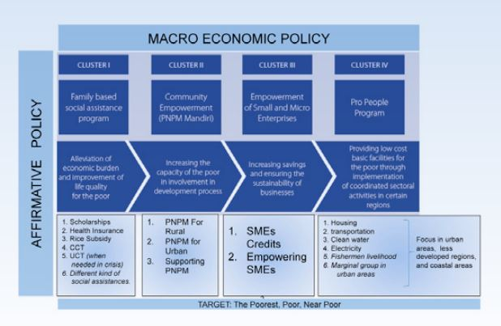

source: https://www.bappenas.go.id/files/7213/8070/7102/Poverty_Reduction_Program_in_Indonesia.pdf

Indonesia’s four social assistance programs that target households (the ‘Cluster 1’ group comprising Raskin, Jamkesmas, BSM and PKH) plus the incidental, non- permanent unconditional cash transfer scheme known as BLSM have laid a good foundation for a comprehensive social welfare regime in the future. The maintenance of these social assistance programs, as well as programs in the other ‘clusters’, means that if the government continues reducing the fuel subsidy, budget can be reallocated to improve the current programs.

The government has also introduced a number of social welfare programs. Following the 2005, 2008 and 2013 fuel subsidy reductions, the government delivered temporary cash transfer programs targeting low-income households, to relieve the burden due to higher prices. Apart from that, the government has also introduced a number of more permanent social assistance programs, which together could be strengthened and improved further into a more comprehensive social welfare system. Indonesia’s experience so far demonstrates the striking complementarily of fuel subsidy and social welfare reforms. One side of the reforms can provide strong justification for the other. There is still much work to do. The government needs to set out a comprehensive plan for energy sector reform aiming to reduce dependency on fossil fuels. Subsidy cuts should be just one part of the larger energy sector reforms, the purpose of which should be to narrow the gap between domestic and international fuel prices, and to make prices more efficiently reflect scarcity. The extra budget derived from fuel subsidy cuts could be reallocated to three broad areas: infrastructure development, public transport facilities and further improvement of social welfare programs. The main social welfare programs in need of greater government funding concern health, nutrition and education.

Obviously, Indonesia has tighter administrative constraints. Thus, the need for economic efficiency greater, and policymakers care about equity considerations seems even stronger. A modestly progressive tax on wage income and a comprehensive low-rate tax on capital income is likely the most one can or should aim. Along these lines, one approach for a personal income tax for developing countries would be one with a roughly equal constant marginal rate imposed.

Despite the challenges it faces, Indonesia’s government does not need to “reinvent the wheel”. It has already developed many instruments that can serve as the building blocks of a more effective and efficient future welfare system. There are two years before tax reforms in Indonesia ends. We believe that it is not something easy to do even the after tax reform is even harder. There are a lot of supports needed from the stakeholders, and we have hope that even though it is not easy, it is not impossible especially to solve this inequality and taxation issues.